VISVESVARAYA TECHNOLOGICAL UNIVERSITY
“JnanaSangama”, Belgaum -590014, Karnataka.

LAB REPORT
on
Object Oriented Java Programming (23CS3PCOOJ)
Submitted by
SAURAV JHA(1BF24CS273)
in partial fulfillment for the award of the degree of
BACHELOR OF ENGINEERING
in

B.M.S. COLLEGE OF ENGINEERING
(Autonomous Institution under VTU)
BENGALURU-560019
Aug-2025 to Jan-2026

B.M.S. College of Engineering,
Bull Temple Road, Bangalore 560019
(Affiliated To Visvesvaraya Technological University, Belgaum)
Department of Computer Science and Engineering

CERTIFICATE
This is to certify that the Lab work entitled “Object Oriented Java Programming (23CS3PCOOJ)” carried out by SAURAV JHA (1BF24CS273), who is a bonafide student of B.M.S. College of Engineering. It is in partial fulfilment for the award of Bachelor of Engineering in Computer Science and Engineering of the Visvesvaraya Technological University, Belgaum. The Lab report has been approved as it satisfies the academic requirements in respect of an Object-Oriented Java Programming (23CS3PCOOJ) work prescribed for the said degree.

Dr. Seema Patil  Associate Professor  Department of CSE, BMSCE | Dr. Kavitha Sooda  Professor & HOD  Department of CSE, BMSCE

Index
Sl.  No. | Date | Experiment Title | Page No.
1 | 23/9/25 | Quadratic Equations | 4-5
2 | 13/10/25 | SGPA Calculator | 6-8
3 | 14/10/25 | Bookstore Program | 9-10
4 | 4/11/25 | Shapes Program | 11-12
5 | 4/11/25 | Bank Program | 13-17
6 | 18/11/25 | Packages | 18-20
7 | 26/11/25 | Errors | 21-22
8 | 9/12/25 | Multi Threading | 23-24
9 | 9/12/25 | Open Ended Question 1 | 25-26
10 | 9/12/25 | Open Ended Question 2 | 27-30

Github Link: https://github.com/sauravjhacs24-web/java-273

Program 1: Implement Quadratic Equation
Code:
import java.util.*;
public class quadratic{
public static void main(String[] args ){
Scanner sc=new Scanner(System.in);
double a,b,c,d;
System.out.println("Enter the value of a ");
a= sc.nextInt();
System.out.println("Enter the value of b");
b= sc.nextInt();
System.out.println("Enter the value of c");
c= sc.nextInt();
if(a==0){
System.out.println("Not a quadratic equation");
}
else{
d=b*b-4*a*c;
if(d==0){
double r1=(-b)/(2*a);
System.out.println("Roots are real and equal");
System.out.println("roots"+r1);

}
else if (d>0) {
double r1=((-b)+(Math.sqrt(d)))/(double)(2*a);
double r2=((-b)-(Math.sqrt(d)))/(double)(2*a);
System.out.println(" roots are "+r1);
System.out.println(" roots are"+r2);
}
else if(d<0){
System.out.println("Roots are imaginary");
double r1= (-b)/(2*a);
double r2= Math.sqrt(-d)/(2*a);
System.out.println("roots are"+r1);
System.out.println("roots are"+r2);
}
}
}
}

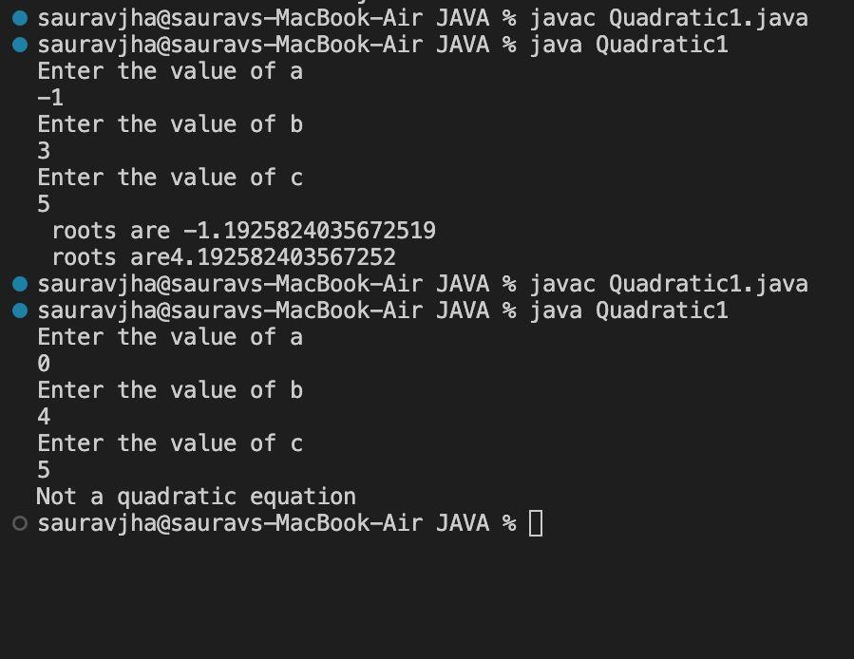

Program 2: SGPA Calculator
Code:
import java.util.Scanner;
class Subject {
int subjectMarks;
int credits;
int grade;
}
class Student {
String name;
String usn;
double SGPA;
Scanner s = new Scanner(System.in);
Subject subject[];
Student() {
subject = new Subject[8]; // 8 subjects
for (int i = 0; i < 8; i++) {
subject[i] = new Subject();
}
}
void getStudentDetails() {
System.out.print("Enter Name: ");
name = s.nextLine();
System.out.print("Enter USN: ");
usn = s.nextLine();
}
void getMarks() {
for (int i = 0; i < 8; i++) {
System.out.println("\nEnter details for Subject " + (i + 1) + ":");
System.out.print("Enter Marks (0–100): ");
subject[i].subjectMarks = s.nextInt();
System.out.print("Enter Credits: ");
subject[i].credits = s.nextInt();
subject[i].grade = (subject[i].subjectMarks / 10) + 1;
if (subject[i].grade == 11)
subject[i].grade = 10;
if (subject[i].grade <= 4)
subject[i].grade = 0;
if (subject[i].subjectMarks > 100 || subject[i].subjectMarks < 0) {
System.out.println("Invalid marks! Setting grade = 0");
subject[i].grade = 0;
}
}
}
void computeSGPA() {
int effectiveScore = 0;
int totalCredits = 0;
for (int i = 0; i < 8; i++) {
effectiveScore += (subject[i].grade * subject[i].credits);
totalCredits += subject[i].credits;
}

SGPA = (double) effectiveScore / totalCredits;
}
void displayDetails() {
System.out.println("\n----------------------------");
System.out.println("Name : " + name);
System.out.println("USN : " + usn);
System.out.printf("SGPA : %.2f\n", SGPA);
System.out.println("----------------------------");
}
}
public class StudentSGPA {
public static void main(String[] args) {
Student st = new Student();
st.getStudentDetails();
st.getMarks();
st.computeSGPA();
st.displayDetails();
}
}
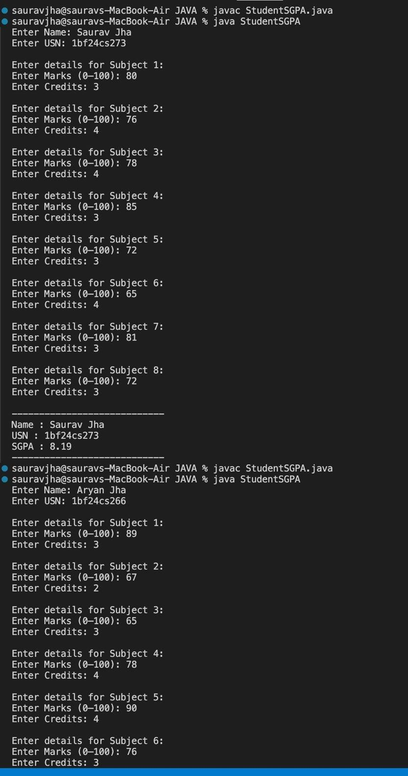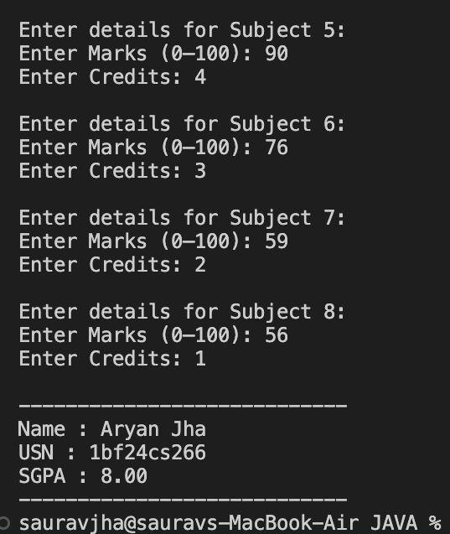

Program 3: Bookstore Program
Code:
import java.util.Scanner;
class Book {
String name;
String author;
int price;
int numPages;
Book(String name, String author, int price, int numPages) {
this.name = name;
this.author = author;
this.price = price;
this.numPages = numPages;
}
public String toString() {
return "Book Name: " + name + "\n"
+ "Author Name: " + author + "\n"
+ "Price: " + price + "\n"
+ "Number of Pages: " + numPages + "\n";
}
}

public class PROGRAM3 {
public static void main(String[] args) {
Scanner s = new Scanner(System.in);
System.out.print("Enter number of books: ");
int n = s.nextInt();
Book[] books = new Book[n];
for (int i = 0; i < n; i++) {
System.out.println("\nEnter details for Book " + (i + 1) + ":");
s.nextLine();
System.out.print("Name: ");
String name = s.nextLine();
System.out.print("Author: ");
String author = s.nextLine();
System.out.print("Price: ");
int price = s.nextInt();
System.out.print("Number of pages: ");
int numPages = s.nextInt();
books[i] = new Book(name, author, price, numPages);
}
System.out.println("\n--- Book Details ---");
for (Book b : books) {
System.out.println(b.toString());
s.close(); } }

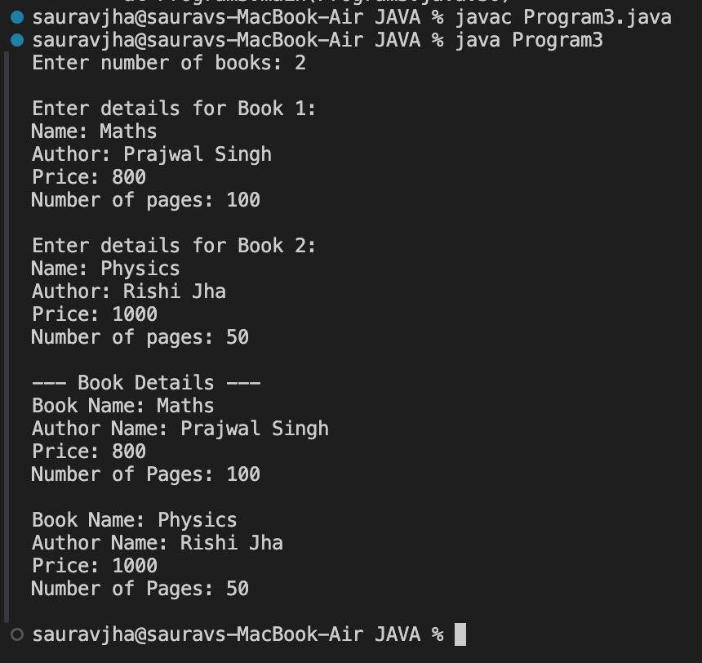

Program 4: Shapes Program
Code:
import java.util.Scanner;
abstract class shape{
int a,b,l,h,d;
abstract void PrintArea();
}
class rectangle extends shape{
rectangle(int x,int y){
a=x;
b=y;
}
void PrintArea(){
System.out.println("Area of rectange="+(a*b));
}
}
class triangle extends shape{
triangle(int x, int y){
l=x;
h=y;
}
void PrintArea(){
System.out.println("AREA OF TRIANGLE="+(h*l*0.5));
}
}
class circle extends shape{
circle(int r){
d = r;
}
void PrintArea(){
System.out.println("Area of circle="+(3.14*d*d));
}
}
public class lab4{
public static void main(String[]args){
Scanner sc=new Scanner(System.in);
shape s;
System.out.println("Enter the dimension of the rectangle:");
int a= sc.nextInt();
int b= sc.nextInt();
s= new rectangle(a,b);
s.PrintArea();
System.out.println("Enter the dimension of the triangle:");
int l= sc.nextInt();
int h= sc.nextInt();
s= new triangle(l,h);
s.PrintArea();
System.out.println("Enter the dimension of the circle:")
int d= sc.nextInt();
s= new circle(d);
s.PrintArea();
sc.close(); } }

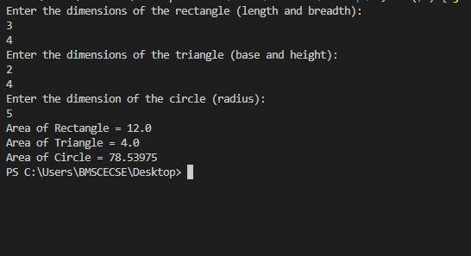

Program 5: Bank Program
Code:
import java.util.Scanner;
class Account {
String customerName;
int accountNumber;
String accountType;
double balance;
Account(String name, int number, String type) {
customerName = name;
accountNumber = number;
accountType = type.toLowerCase();
balance = 0.0;
}
void deposit(double amount) {
balance += amount;
System.out.println("Deposited: " + amount + ". Updated balance: " + balance);
}
void display() {
System.out.println("Customer name: " + customerName);
System.out.println("Account number: " + accountNumber);
System.out.println("Type of ACCOUNT: " + (accountType.equals("saving") ? "Savings account" : "Current account"));
System.out.println("Balance = " + balance);
}
}
class Sav_acct extends Account {
Sav_acct(String name, int number) {
super(name, number, "saving");
}
void computeInterest() {
double interest = balance * 0.04; // 4% interest rate
balance += interest;
System.out.println("Interest added: " + interest + ". Updated balance: " + balance);
}
void withdraw(double amount) {
if (amount > balance) {
System.out.println("Insufficient balance!");
} else {
balance -= amount;
System.out.println("Withdrawn: " + amount + ". Updated balance: " + balance);
}
}
}
class Cur_acct extends Account {
final double minBalance = 500;
final double serviceCharge = 50;

Cur_acct(String name, int number) {
super(name, number, "current");
}
void checkBalance() {
if (balance < minBalance) {
balance -= serviceCharge;
System.out.println("Balance below minimum. Service charge of Rs." + serviceCharge + " imposed.");
}
}
void withdraw(double amount) {
if (amount > balance) {
System.out.println("Insufficient balance!");
} else {
balance -= amount;
checkBalance();
System.out.println("Withdrawn: " + amount + ". Updated balance: " + balance);
}
}
}
public class bank {
public static void main(String[] args) {
Scanner sc = new Scanner(System.in);
System.out.print("Enter customer name: ");
String name1 = sc.nextLine();
System.out.print("Enter account number: ");
int accNum1 = sc.nextInt();
sc.nextLine();
System.out.print("Enter customer name: ");
String name2 = sc.nextLine();
System.out.print("Enter account number: ");
int accNum2 = sc.nextInt();
sc.nextLine();
Sav_acct sAcc = new Sav_acct(name1, accNum1);
Cur_acct cAcc = new Cur_acct(name2, accNum2);
int choice;
do {
System.out.println("\n-------MENU-------");
System.out.println("1. Deposit");
System.out.println("2. Withdraw");
System.out.println("3. Compute Interest for Savings Account");
System.out.println("4. Display account details");
System.out.println("5. Exit");
System.out.print("Enter your choice: ");
choice = sc.nextInt();
sc.nextLine();
switch (choice) {
case 1:
System.out.print("Enter the type of account (saving/current): ");
String type1 = sc.nextLine().toLowerCase();
System.out.print("Enter the deposit amount: ");
double depAmt = sc.nextDouble();
sc.nextLine();
if (type1.equals("saving"))
sAcc.deposit(depAmt);
else
cAcc.deposit(depAmt);
break;
case 2:
System.out.print("Enter the type of account (saving/current): ");
String type2 = sc.nextLine().toLowerCase();
System.out.print("Enter the withdrawal amount: ");
double withAmt = sc.nextDouble();
sc.nextLine();
if (type2.equals("saving"))
sAcc.withdraw(withAmt);
else
cAcc.withdraw(withAmt);
break;
case 3:
System.out.print("Enter the type of account (saving/current): ");
String type3 = sc.nextLine().toLowerCase();
if (type3.equals("saving"))
sAcc.computeInterest();
else
System.out.println("No interest for current account.");
break;
case 4:
System.out.print("Enter the type of account (saving/current): ");
String type4 = sc.nextLine().toLowerCase();
if (type4.equals("saving"))
sAcc.display();
else
cAcc.display();
break;
case 5:
System.out.println("Exiting...");
break;
default:
System.out.println("Invalid choice!");
}
} while (choice != 5);

sc.close();
}
}

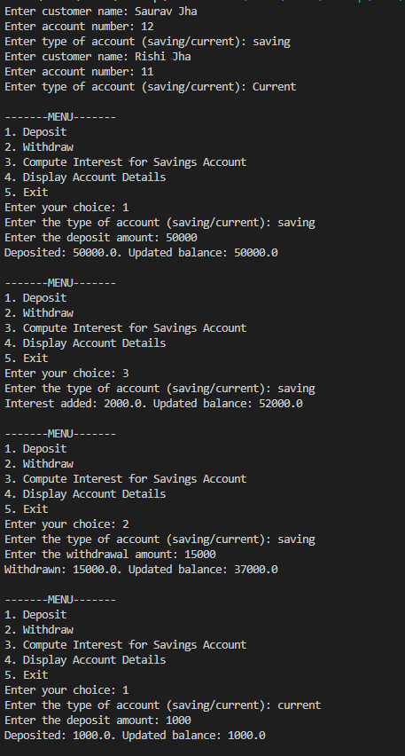
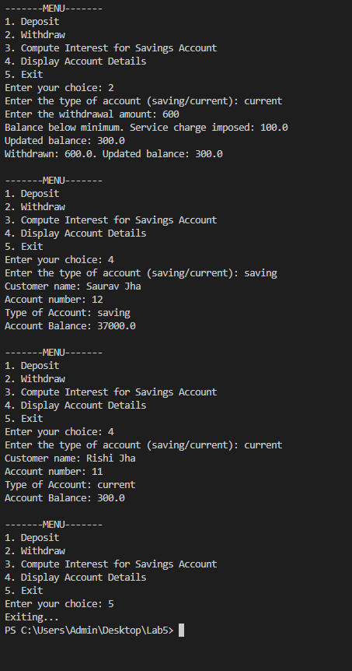
Program 6: Packages
Code:
package CIE;
public class Student {
public String usn, name;
public int sem;
public Student(String usn, String name, int sem) {
this.usn = usn;
this.name = name;
this.sem = sem;
}
}
package CIE;
public class Internals extends Student {
public int[] internal = new int[5];
public Internals(String usn, String name, int sem, int[] internal) {
super(usn, name, sem);
for (int i = 0; i < 5; i++)
this.internal[i] = internal[i];
}
}
package CIE;
public class Internals extends Student {
public int[] internal = new int[5];
public Internals(String usn, String name, int sem, int[] internal) {
super(usn, name, sem);
for (int i = 0; i < 5; i++)
this.internal[i] = internal[i];
}
}
package SEE;
import CIE.Student;
public class External extends Student {
public int[] see = new int[5];
public External(String usn, String name, int sem, int[] see) {
super(usn, name, sem);
for (int i = 0; i < 5; i++)
this.see[i] = see[i];
}
}
import CIE.*;
import SEE.*;
import java.util.*;
public class FinalMarks {
public static void main(String[] args) {
Scanner sc = new Scanner(System.in);

System.out.print("Enter number of students: ");
int n = sc.nextInt();
Internals[] ci = new Internals[n];
External[] se = new External[n];
for (int i = 0; i < n; i++) {
System.out.println("\nEnter details of student " + (i+1));

System.out.print("USN: ");
String usn = sc.next();

System.out.print("Name: ");
String name = sc.next();

System.out.print("Semester: ");
int sem = sc.nextInt();

int[] internal = new int[5];
int[] see = new int[5];

System.out.println("Enter internal marks (5 courses):");
for (int j = 0; j < 5; j++)
internal[j] = sc.nextInt();

System.out.println("Enter SEE marks (5 courses):");
for (int j = 0; j < 5; j++)
see[j] = sc.nextInt();

ci[i] = new Internals(usn, name, sem, internal);
se[i] = new External(usn, name, sem, see);
}

System.out.println("\nFINAL MARKS:");
for (int i = 0; i < n; i++) {
System.out.println("\nStudent: " + ci[i].name + " (" + ci[i].usn + ")");
for (int j = 0; j < 5; j++) {
int finalMarks = ci[i].internal[j] + (se[i].see[j] / 2);
System.out.println("Course " + (j+1) + ": " + finalMarks);
}
}
}
}

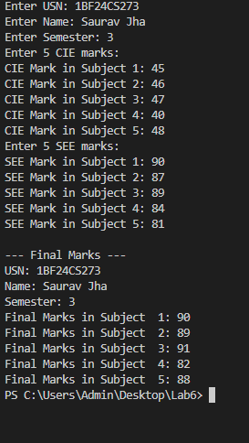

Program 7: Errors
Code:
import java.util.Scanner;
class WrongAge extends Exception{
public WrongAge(String msg) {
super(msg);
}
}
class Father{
int FatherAge;
Father() throws WrongAge{
Scanner sc=new Scanner(System.in);
System.out.println("Enter Fathers Age: ");
FatherAge=sc.nextInt();
if(FatherAge<0){
throw new WrongAge("FATHERS AGE CANNOT BE NEGATIVE");
}
}
}
class Son extends Father{
int SonAge;
Son()throws WrongAge{
super();
Scanner sc=new Scanner (System.in);
System.out.println("Enter Sons Age:");
SonAge=sc.nextInt();
if(SonAge>=FatherAge){
throw new WrongAge("Sons age is greater than fathers age");
}
else if (SonAge<0){
throw new WrongAge("Sons Age cannot be negative");
}
}
void display(){
System.out.println("Sons Age:"+SonAge);
System.out.println("Fathers Age:"+FatherAge);
}
}
public class InheritanceAgeDemo{
public static void main(String [] args){
try{
Son S=new Son();
System.out.println();
S.display();

System.out.println("---Details----");
S.display();

}
catch(WrongAge e){
System.out.println("Exception:" +e.getMessage());
}
}
}

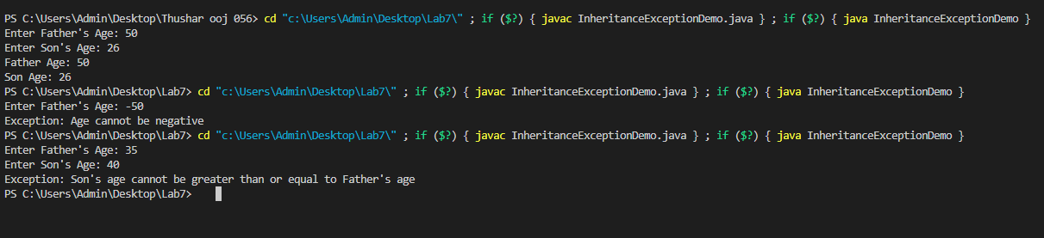

Program 8: Multi Threading
Code:
class MessageThread extends Thread {
String message;
int interval;
int count;

MessageThread(String msg, int time, int count) {
this.message = msg;
this.interval = time;
this.count = count;
}

public void run() {
try {
for (int i = 1; i <= count; i++) {
System.out.println(message);
Thread.sleep(interval);
}
} catch (InterruptedException e) {
System.out.println("Thread Interrupted");
}
}
}

public class Main {
public static void main(String[] args) {

MessageThread t1 = new MessageThread("BMS College of Engineering", 10000, 5);

MessageThread t2 = new MessageThread("CSE", 2000, 10);

t1.start();
t2.start();
}
}

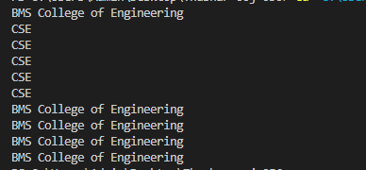

Program 9: Open Ended Question 1
Code:
import javax.swing.*;
import java.awt.*;
import java.awt.event.*;

public class DivisionUI extends JFrame implements ActionListener {
JTextField num1Field, num2Field, resultField;
JButton divideButton;
DivisionUI() {
setTitle("Integer Division");
setSize(350, 200);
setDefaultCloseOperation(JFrame.EXIT_ON_CLOSE);
setLayout(new GridLayout(4, 2, 5, 5));
add(new JLabel("Num 1:"));
num1Field = new JTextField();
add(num1Field);
add(new JLabel("Num 2:"));
num2Field = new JTextField();
add(num2Field);
divideButton = new JButton("Divide");
add(divideButton);
divideButton.addActionListener(this);
add(new JLabel("Result:"));
resultField = new JTextField();
resultField.setEditable(false);
add(resultField);
setVisible(true);
}
public void actionPerformed(ActionEvent e) {
try {
int num1 = Integer.parseInt(num1Field.getText());
int num2 = Integer.parseInt(num2Field.getText());

if (num2 == 0) {
throw new ArithmeticException("Cannot divide by zero");
}
int result = num1 / num2;
resultField.setText(Integer.toString(result));
} catch (NumberFormatException ex) {
JOptionPane.showMessageDialog(this,
"Please enter valid integers!",
"Number Format Error",
JOptionPane.ERROR_MESSAGE);
}

catch (ArithmeticException ex) {
JOptionPane.showMessageDialog(this,
ex.getMessage(),
"Arithmetic Error",
JOptionPane.ERROR_MESSAGE);
}
}
public static void main(String[] args) {
new DivisionUI();
}
}

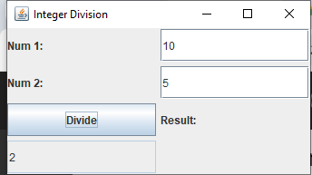

Program 10: Open Ended Question 2
Code:
class Q {
int n;
boolean valueSet = false;
synchronized int get() {
while (!valueSet) {
try {
System.out.println("\nConsumer waiting\n");
wait();
} catch (InterruptedException e) {
System.out.println("InterruptedException caught");
}
}
System.out.println("Got: " + n);
valueSet = false;
System.out.println("\nIntimate Producer\n");
notify();
return n;
}
synchronized void put(int n) {
while (valueSet) {
try {
System.out.println("\nProducer waiting\n");
wait();
} catch (InterruptedException e) {
System.out.println("InterruptedException caught");
}
}
this.n = n;
valueSet = true;
System.out.println("Put: " + n);
System.out.println("\nIntimate Consumer\n");
notify();
}
}
class Producer implements Runnable {
Q q;
Producer(Q q) {
this.q = q;
new Thread(this, "Producer").start();
}
public void run() {
int i = 0;
while (i < 5) {
q.put(i++);
}
}
}

class Consumer implements Runnable {
Q q;
Consumer(Q q) {
this.q = q;
new Thread(this, "Consumer").start();
}
public void run() {
int i = 0;
while (i < 5) {
int r = q.get();
System.out.println("Consumed: " + r);
i++;
}
}
}
public class main {
public static void main(String args[]) {
Q q = new Q();
new Producer(q);
new Consumer(q);
System.out.println("Press Control-C to stop.");
}
}

